AUTOMATED ALGORITHMIC ACCIDENT PREVENTION SYSTEM
Sudharsan K¹, Gunaseelan K², Hari Haran B³, Prof. Balaji S⁴
^{1, 2, 3} UG Student, Dept. of Computer Science, Panimalar Engineering College, Chennai, Tamil Nadu, India
⁴Assistant Professor, Dept. of Computer Science, Panimalar Engineering college, Chennai, TamilNadu, India

---------------------------------------------------------------------***---------------------------------------------------------------------

Abstract - The main impact of this project is to minimize the number of accidents occurring now-a-days. Thus we come up with solution for the following problems. First, Now-a-days, more number of accidents occurs during the time of Mist season due to invisibility of ahead vehicles by the drivers and we can resolve this by intimating the distance between the current and ahead vehicles to the driver using VFDT Algorithm. The next main reason for the accidents is, in normal times during traffic or overtaking the vehicle, the driver cannot able to predict the amount of brake applied by the before vehicle so the vehicle went to an accident with the before vehicle and thus the upcoming vehicles also get damaged. Thus we can resolve it by placing the LCD display at the Vehicle. Suppose if accidents occurred beyond the drivers control then our proposed system suddenly sends an info about the accident to the registered persons . Our proposed concept can be implement using IoT domain which performs all the above tasks.
Key Words: Arduino UNO, UltraSonic Sensor, Crash Sensor, LCD Display, GSM Module, GPS Module, VFDT Algorithm.

1.INTRODUCTION

Now-a-days most of the accidents are occurring during the Mist Season. During this season the Vehicle Drivers cannot able to have the clear vision of the before vehicles or road. Thus in majority time it may results in an Accidents. There is no chance to stop the Vehicle by the Drivers during such situation because they may travel at high speed and they will see the Vehicle when reaches the before Vehicle most closely. Our Proposed Model will intimate them when they drive the vehicle very closely to the another vehicle by displaying an information about the Distance between the current and ahead vehicles with the help of Ultrasonic Sensor and VFDT Algorithm (which alerts the user according to the driven speed) via LCD Display or LCD Monitor which will be placed in-front of Driver Seat. The another problem is that, in normal times during traffic or while attempting to overtake the vehicle, the driver cannot able to predict the amount of brake applied by the before vehicle so the vehicle went to an accident with the before vehicle and thus the upcoming vehicles also get damaged. Thus we can resolve it with our proposed concept, by placing the LCD Display at the backside of the Vehicle which will be useful for the rear Vehicle driver to detect the speed and distance of the front vehicle and make to manage their vehicle according to the displayed distance and the drivers will undergo the respective actions. Suppose if an accident occurs beyond the control of the drivers, the Crash Sensor which is placed in our proposed system will intimate to the Arduino which inturns initialize the GPS Module which sends an data about the accident to the registered persons along with the current location of the Vehicle.

2. LITERATURE SURVEY

[1] The “Detection and Prediction of Driver Drowsiness Using Artificial Neural Network Models” premise is based on continuous drowsiness monitoring. The goal of this study is to see if the same information that is used to identify tiredness can also be used to forecast when a certain degree of tiredness will be reached. In this journal, the author uses Deep Learning ideas of Neural Networks to predict the amount of drowsiness in a driver and also to make an alert for car drivers when they have more sleepiness without their knowledge, which helps to prevent accidents while driving at night. Furthermore, we will monitor and take survey about whether incorporating data such as driving duration and drivers information about increases the accuracy of sleepiness detection and prediction.

[2] “IMPLEMENTATION OF VEHICLE MONITORING AND TRACKING SYSTEM USING NODE-MCU” using the IoT Concepts. This Journal is mainly concentrate on the monitoring of the Vehicle by using various sensors to predict the present condition of the vehicle. . If any distraction had occurred in Vehicle, this module will able to identifies the location of the vehicle parts and sends the information about the status and current location of the vehicle to the particular user using the modules like NodeMCU, GSM SIM 900. This review results in the identification and transfer the information about the status of Vehicle.

[3] The concept of VDFT Algorithm which is useful for the fast retrieval of Information from the Big Database which also react according to the number of records in the Database. In the era of Big Data where voluminous data is handled by very large scale, the traditional decision trees might have very effective time consuming and sometimes might even fail or inconsistent to work due to its dataset size. By analyzing data using Big Data can also be a costly affair due to its high demand for memory and other hardware requirements. We have chosen a decision tree algorithm named Very Fast Decision Tree (VFDT) which is effective rather than the other decision tree algorithms like ID3 and C4.

3. EXISTING SYSTEM

The Existing System consist of only sensors to detect the distance between the previous vehicles or obstacles which always alerts the users even while passing the vehicles when the system works which irritates them always.

4. PROPOSED SYSTEM

Our Proposed System consist of VFDT Algorithm which does not give alert always, it alerts when the speed of the vehicle is constantly high and the distance between vehicle decreases exponentially during Mist season. Our system involves LCD display which is placed at rear side of each vehicle which helps the upcoming vehicle to predict the distance between the current and prior vehicle and also they can able to manage the speed of vehicle according to it. Suppose an accident is occurred, then our system will gather the information about the current location of the vehicle and send an information to the corresponding registered users.

5. MODULES

5.1 Ultrasonic and Crash Sensor

Ultrasonic sensors measure distance by passing ultrasonic waves. The sensor head emits an ultrasonic wave and receives the wave which has been reflected back from the target. It measures the distance to the target by measuring the time between the emission and reception.
The distance can be calculated with the following formula: Distance L = 1/2 × T × C
Crash sensors collect the data necessary to make decision when an accident occurs. Crash sensors measure how quickly a vehicle crash with before vehicle and also accelerates to the side in a side-impact crash. Some vehicles consist of a sensing system which has been designed to detect the onset of a rollover crashes. Frontal crash sensors may be located at the front of the vehicle near the engine, and also at the sides of vehicle, or sometimes in the electronic control unit (ECU).

5.2 LCD DISPLAY / MONITOR

The LCD Display (Liquid Crystal Display) on the Arduino is a form of display that runs on liquid crystals. We'll take serial input from the computer and upload the sketch to the Arduino from here. On the LCD, the characters will be shown. LCD technology allowed for significantly thinner displays than cathode ray tube (CRT) technology. LCDs use a lot less energy than LEDs. A backlight illuminates the liquid crystals in an LCD, resulting in a picture. Overall, displaying the data evaluated by the Sensor is beneficial.

5.3 GPS MODULE

The Global Positioning System (GPS) is a gadget that can receive information from GNSS satellites and then compute its geographic position. It is one of the Global Navigation Satellite Systems (GNSS), which gives geolocation and time information to a GPS receiver anywhere on or near the Earth when four or more GPS satellites can be seen without obstruction. The GPS does not require the user to send any data, and it works independently of telephonic or internet reception, however both technologies can improve the accuracy of GPS positioning data.

5.4 GSM MODULE

A GSM or GPRS module is a circuited chip that allows a mobile device or a connected modules to communicate with a GSM or GPRS system. This module can be used to send a message to a registered phone number (which should be configure in GSM Module)

5.5 VFDT Algorithm

Proposes to implement and use the very fast decision tree (VFDT) algorithm can effectively perform a test-and-train process with a limited segment of data. In contrast with traditional algorithms, the VFDT does not require that the full dataset be read as part of the learning process thus reducing time. As a preemptive approach to minimizing the impacts of imperfect data streams, a data cache and missing-data-guessing mechanism called the auxiliary reconciliation control is proposed to function as a within VFDT. We have also conducted an extensive analysis on various datasets which have proved our proposed algorithm to be more efficient in terms of time compared to the other existing decision tree models. This implementation can form a base for a large number of applications for handling Big Data. We have replaced the serial execution of VFDT algorithm by a series of Map and Reduce functions.

6. SYSTEM ARCHITECTURE

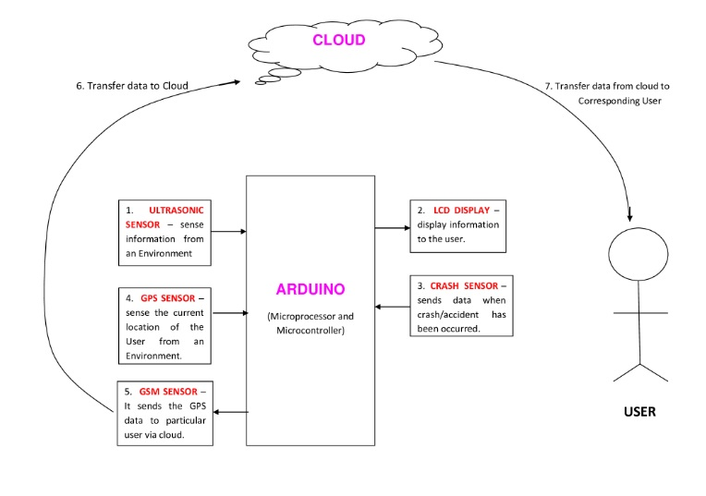

7. USECASE DIAGRAM
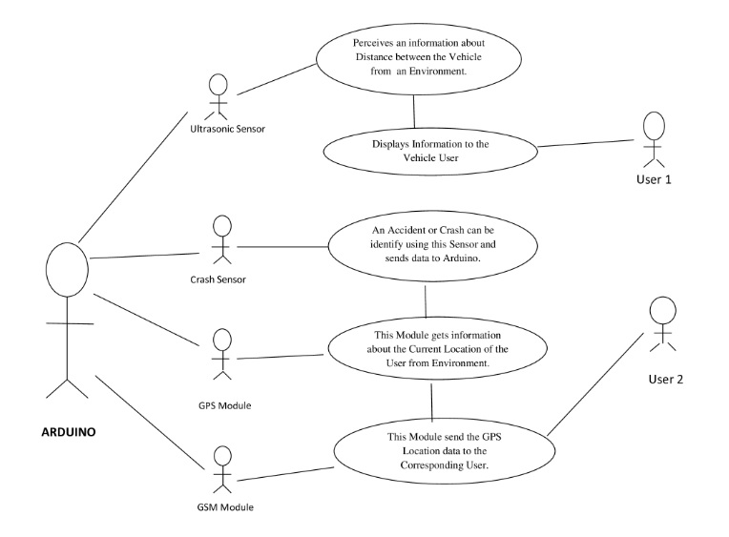

8. FLOW DIAGRAM

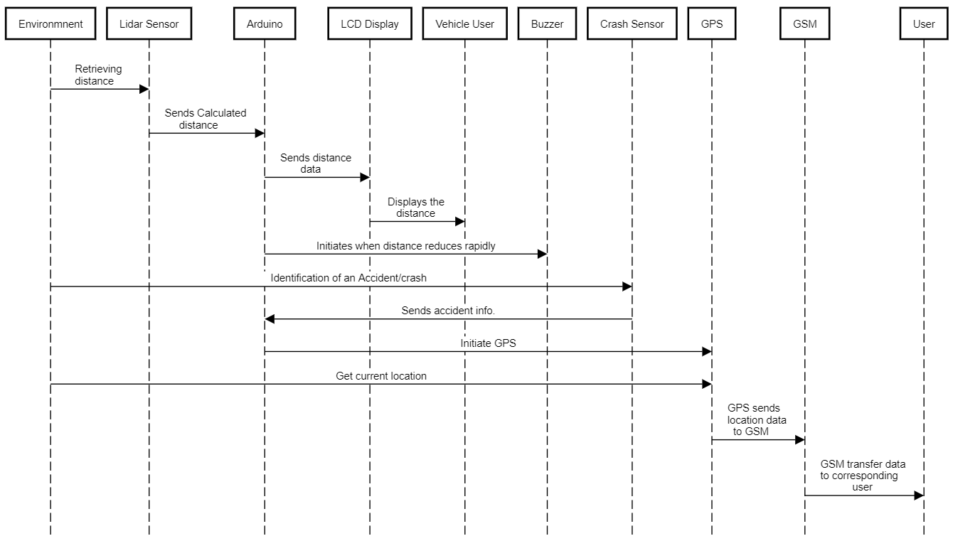

9. HARDWARE REQUIREMENTS

Processor | Core i3, 2.4 GHz
Hard disk | 500 GB
RAM | 4GB
Monitor / LCD Display | 14/15 inches Color
Sensors | Ultrasonic Sensor  Crash Sensor
Modules | Arduino UNO Board  GSM Module  GPS Module

10. SOFTWARE SPECIFICATION

10.1 Arduino

Writing code and uploading it to the board is simple with the open-source Arduino Software (IDE). Any Arduino board can be used with this software. The Arduino Integrated Development Environment (IDE) is a cross-platform application written in C and C++ functions for Windows, macOS, and Linux. It's used to write and upload programmes to Arduino-compatible boards, as well as other vendor development boards with the support of third-party cores. The GNU General Public License, version 2 is used to licence the IDE's source code. The Arduino IDE has specific code structuring guidelines to support the languages C and C++. The Wiring project is a software library that is included with the Arduino IDE and provides numerous common input and output processes. User-written code just needs two basic functions to start the sketch and the main programme loop, which are compiled and linked into an executable cyclic executive programme with the GNU toolchain, which is also included with the IDE release. The Arduino IDE uses the avrdude programme to convert executable code into a text file in hexadecimal encoding, which is then loaded into the Arduino board's firmware via a loader software.

10.2 Embedded System
An Embedded System is a computer-hardware system that has software embedded in it, allowing it to be used for a range of applications or a specific portion of an application or product, or as part of a larger system.
An embedded system might be a small stand-alone system or a huge multi-system setup. Embedded C is the most widely used programming language in the software industry for creating electronic devices. Embedded C programming is essential for the CPU to fulfil its unique function. It is a microcontroller-based control system that is used to carry out a specified task.
An embedded system is a combination of three major components:
Hardware: An embedded system's hardware is a physically used component that is physically attached to it. It includes a microcontroller-based integrated circuit, a power supply, and an LCD display, among other things.
Application software: By altering the code stored in an embedded system, application software allows the user to run a variety of applications on the system.
Real Time Operating system (RTOS): The way an embedded system works is supervised by the RTOS. It serves as a bridge between hardware and application software, supervising the latter and providing a mechanism for allowing the processor to execute on the basis of scheduling in order to control the impact of latencies.

11. EXPLANATION

The Arduino plays a major role in this project which works based on the IoT Domain. The Arduino is the set of Microprocessor and Microcontroller. The Microcontroller is used to access and control of the entire operation in the system. The Arduino works with the help of the power supply of minimum 9V. The Ultrasonic Sensor which is connected to an Arduino acts as an Input digital value. This sensor will always sense the distance between the current and previous vehicle from an Environment. The calculated value of distance must be send to the LCD Display via Arduino. The LCD Display continuously displays the distance between the vehicle to the driver. This system will gives an alert via buzzer to the driver, only when the speed of the vehicle is high and when the distance between the vehicle decreases exponentially. This can be detected with the help of VFDT (Very Fast Decision Tree) Algorithm.

The LCD Display also placed at rear side of each vehicle which will displays the distance between the current vehicle and previous vehicle. Thus it helps the upcoming vehicle to predict the distance and control their vehicle. Since the ultrasonic sensor covers the distance only upto 11meter. We have used the Lidar (Light Detection and Ranging) sensor which diverse the range upto 400 meters. It's a technique for estimating ranges (varying distance) that involves using a laser to target an object and measuring the time it takes for the reflected light to return to the receiver. The Crash Sensor connected to an Arduino which should be placed at the front of the vehicle. It will be activate when an accident or crash has occurred. When it is activated, it sends information to the GPS (Global Positioning System) Module via an Arduino. The GPS Module will get the current Location of the vehicle and pass the latitude and longitude of location to the GSM Module.

12. CONCLUSION

This guidance system provides the required and useful information about the distance between vehicle to the present vehicle driver during mist season and to upcoming vehicle driver during every time via the LCD Display which reduces the number of accidents. This proposed model also alerts the driver when the distance between vehicle reduced exponentially or rapidly. Suppose an accident or crash has been occurred our system will gets information about location from an environment and transfer it to the corresponding user via GSM.

13. FUTURE ENHANCEMENT

In the further enhancement we are planning transfer the data/information to the corresponding user via inbuilt Wi-Fi after implementing more security measures while transferring data via cloud. In addition to that we have planned to observe the changes of speed of the vehicle via GPS which reduce the number of components.

14. REFERENCES

[1] Charlotte Jacobe-de-Naurois, ChristopheBourdin, AncaStratulat”, “DETECTION AND PREDICTION OF DRIVER DROWSINESS USING ARTIFICIAL NEURAL NETWORK MODELS”, published on May 2019 in Science Direct Journal.

[2] Boddapati Venkata sai Padmaja, Venkata Ratnam Kolluru , Syam Sai Kota, “IOT BASED IMPLEMENTATION OF VEHICLE MONITORING AND TRACKING SYSTEM USING NODE MCU”, published on April 2019 in International Journal of Innovative Technology and Exploring Engineering (IJITEE).

[3] B Devi, S Sai bavatharini, “VEHICULAR SENSING AND AUTOMATIC BRAKING FOR ACCIDENT AVOIDANCE ON THE JUNCTIONS AND BLIND CURVES”, published on July 2018 in International Journal of Pure and Applied Mathematics.

[4] A.Anusha “Vehicle Tracking and Monitoring System to Enhance the Safety and Security Driving Using IoT” 2017 International Conference on Recent Trends in Electrical, Electronics and Computing Technologies (ICRTEECT), July 2017.

[5] Sharmishta Desai, Sourav Roy, Brina Patel, “Very Fast Decision Tree (VFDT) algorithm on Hadoop”, published on August 2016, in IEEE journal.

